**28 Dec 2018** **The Weekly Bulletin of Rotary Club of Kathmandu Mid-Town** **bc-14.12/018**

|  |
| --- |
| C:\Users\Public\Documents\RIP T1819_EN.png |

District: 3292 Web:www.rotarymidtown.org.np Club Id: 26776

**DECEMBER IS DISEASE PREVENTION AND TREATMENT** **MONTH**

Rotary is dedicated to six areas of focus to build international relationships, improve lives, and create a better world. All global grant activities are required to align with the goals of an area of focus.

Disease prevention and treatment is one of the six areas of focus.

For disease prevention and treatment, the goals are:

1. Improve the capacity of local health care professionals

2. Promote disease prevention programs, with the goal of limiting the spread of communicable diseases and reducing the incidences of non-communicable diseases and their complications

3. Enhance local communities’ health infrastructure

4. Educate and mobilize communities to help prevent the spread of major diseases

5. Prevent physical disability resulting from disease or injury

6. Support studies for career-minded professionals related to disease prevention and treatment

21 Dec 018 Friday

**Club Meeting # 1469**

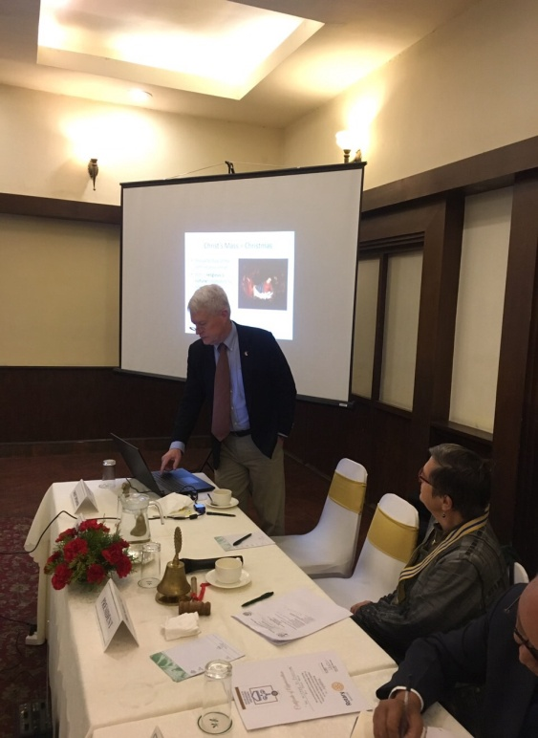 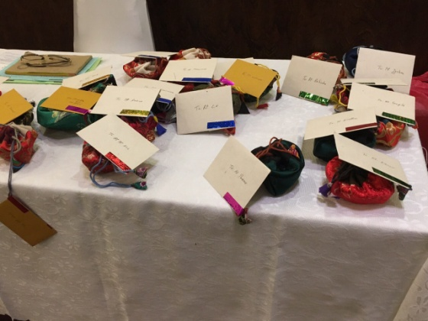 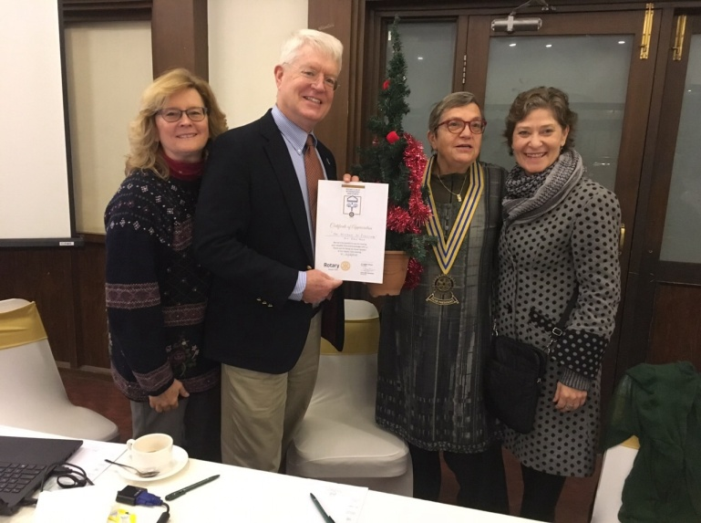

In-house speaker Dale Mole talking Christmas greeting cards Rtn Dale accepting letter of appreciation

*Photo courtesy: Rtn Shyam R Thapalia*

**Weekly Meeting on Friday, 28 Dec 2018**

Our guest speaker is Dr Milan Maharjan.

She will be talking on “Preventing hearing loss among Nepalese children”.

Milan completed medicine from Sun-Yat Sen Medical College, Peoples Republic of China under government scholarship in 1998. She completed masters in Ear Nose Throat from B. P. Koirala Institute of Health Science, Nepal in 2005 and became Fellow from St.Vincent Hospital, Sydney, Australia in 2007.

Dr Milan worked in Kathmandu Medical College, Kathmandu from 2005-2013. In 2013 she decided to leave a permanent job and established Ear Care Nepal. Since then she is the Chairperson and full time volunteer for Ear Care Nepal.

**Public Relations:**

Historically Rotarians perpetuated a myth that Rotary should not seek publicity, but rather let our good works speak for themselves. However, an early stated policy observed that “as a means of extending Rotary’s influence, proper publicity should be given to a worthwhile project well carried out.” A more modern public relations philosophy was adopted in the mid-1970s that affirms that “good publicity, favorable public relations and a positive image are desirable and essential goals for Rotary,” if it is to foster understanding, appreciation and support for its Object and programs and to broaden Rotary’s service to humanity.

The role of the club public relations committee is to develop and execute a plan to tell the public about Rotary and promote the club’s service projects and activities. Having strong public relations ensures that communities around the world know that Rotary is a credible organization that meets real needs.

When a Rotary club has a positive public image, current members are motivated to be active and prospective members are eager to join. Public image and membership growth are interconnected. A high quality, consistent public image campaign will prompt individuals to seek out local clubs and be more inclined to accept invitations to join.

*Source: Internet*

**Walkers’ Circle:**

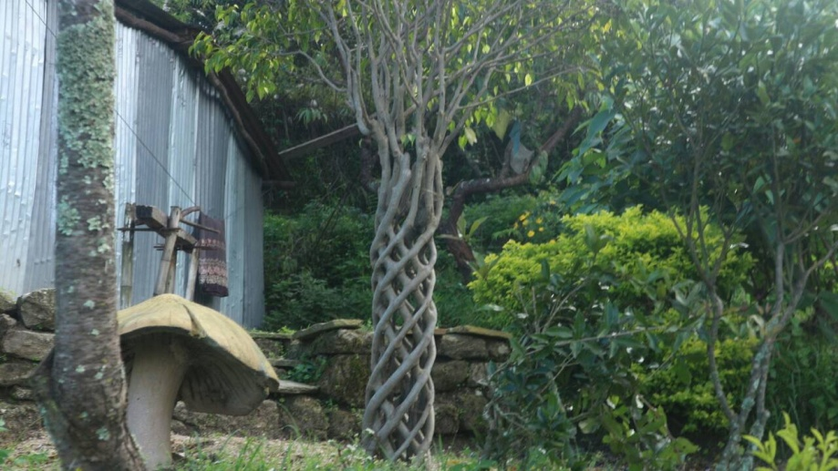 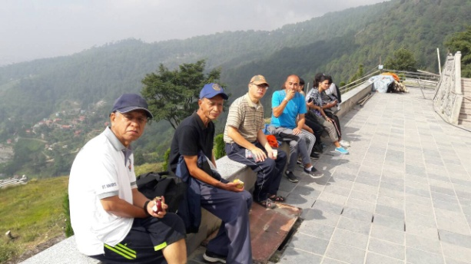 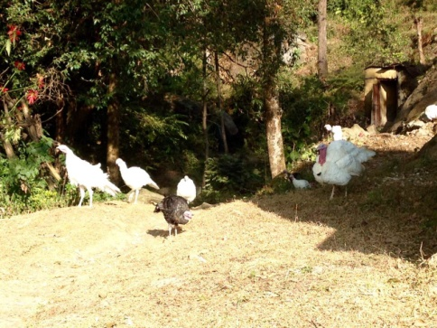

*Photo courtesy: Rtn William Ma*

**Three things in life:**

3 things in life once gone never come back : **Words; Opportunity; Time**

3 things in life are never sure : **Dreams; Success; Fortune**

3 things in life that make you a great person : **Hard work; Sincerity; Forgiveness**

3 things in life are most valuable : **Love; Respecting others; Friends**

3 things in life must not be lost : **Understanding; Trust; Hope**

3 things in life that ensure success : **Confidence; Commitment; Honesty**

3 things in life will destroy a person : **Greed; Boast; Anger**

**A THOUGHT FOR TODAY:**

**The challenge of leadership is  to be strong, but not rude; be kind, but not weak;   
 be bold, but not bully; be thoughtful, but not lazy; be humble, but not timid;**

**be proud, but not arrogant; have humor, but without folly.**

- *Jim Rohn* */ Internet*

On Lighter Side:

The farmer's son was returning from the market with the crate of chicken's his father had entrusted to him, when all of a sudden the box fell and broke open.

Chickens scurried off in different directions, but the determined boy walked all over the neighbourhood scooping up the wayward birds and returning them to the repaired crate.

Hoping he had found them all, the boy reluctantly returned home, expecting the worst.

"Pa, the chickens got loose," the boy confessed sadly, "but I managed to find all twelve of them."

"Well, you did real good, son," the farmer beamed.

"You left with seven!"

On Rotary International Convention:

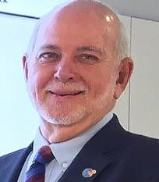

If you I sent in my registration … never suspecting that the experience would change my life.

When I walked through the doors of that convention, I was stunned. ..… That convention

didn’t just open my eyes. It opened my mind. It inspired me to completely change the way

I saw Rotary, what Rotary could do for me, and what I could do through Rotary.

That inspiration has stayed with me ever since — and is renewed every year, at every

Rotary convention.

**RI President Barry Rassin**

Please send information on club activities, progress reviews on service projects, relevant photos etc to:

BC Editor: RR Shrestha email: rryesrr@gmail.com

## 28 Dec 2018 The Weekly Bulletin of Rotary Club of Kathmandu Mid-Town bc-14.12/018

**Wishing you all a Very Happy New Year 2019**

